Big Data Analytics

Sqoop Assignment 1

# Amit Sawant

# Question 1:

## Command:

sqoop import \

--connect jdbc:mysql://localhost/loudacre \

--username training --password training \

--target-dir /axs173331/loudacre/pset1 \

--query 'SELECT first_name, last_name, acct_num, city ,state

from accountdevice join accounts on (account_id = acct_num) where $CONDITIONS

AND account_id IN (select account_id from accountdevice)

group by account_id having count(device_id)=1 ' \

-m 1

## Output:

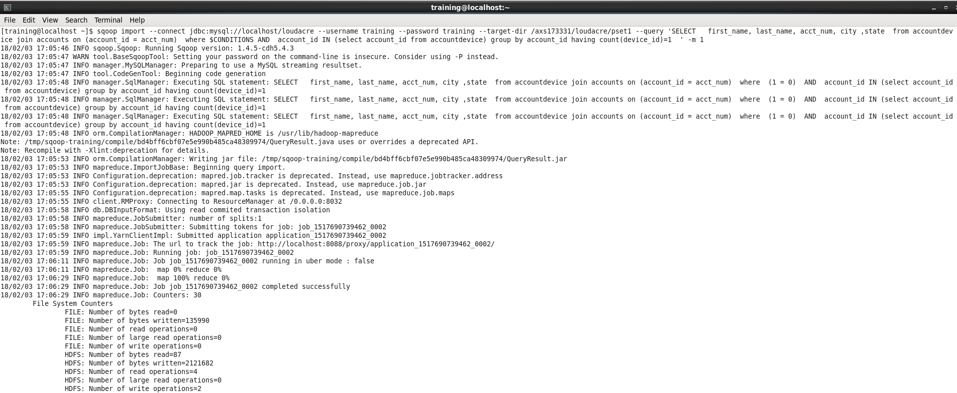

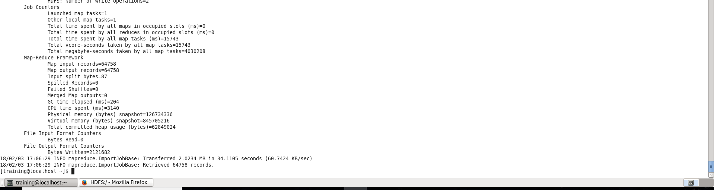

HDFS Command line Output

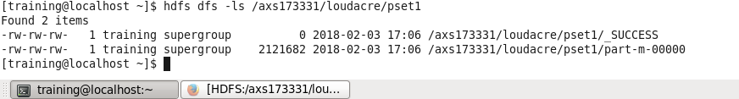

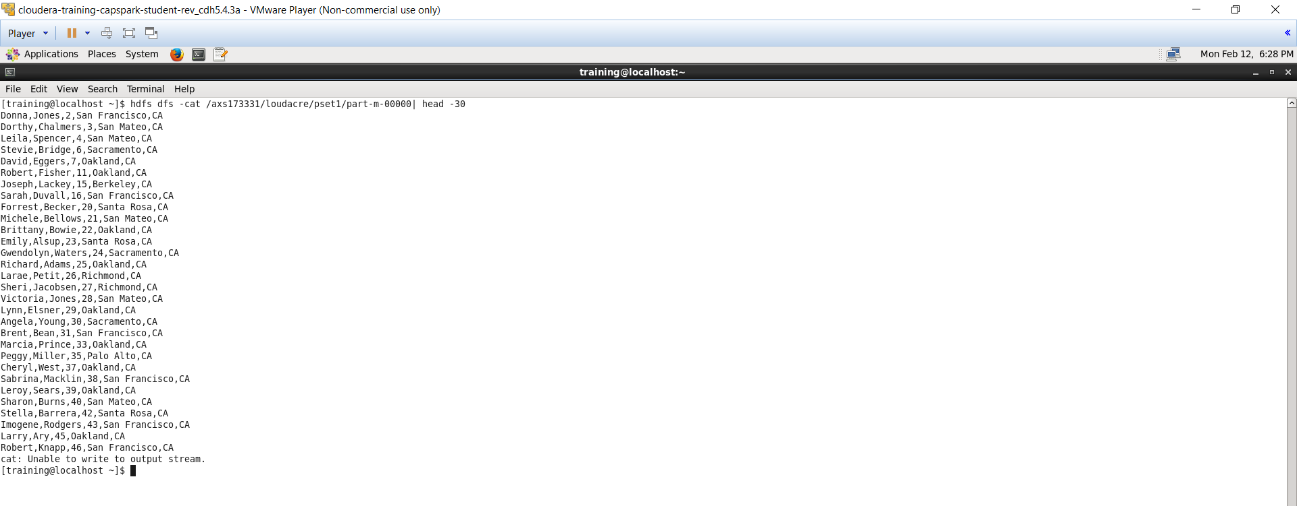

HDFS Browser Output

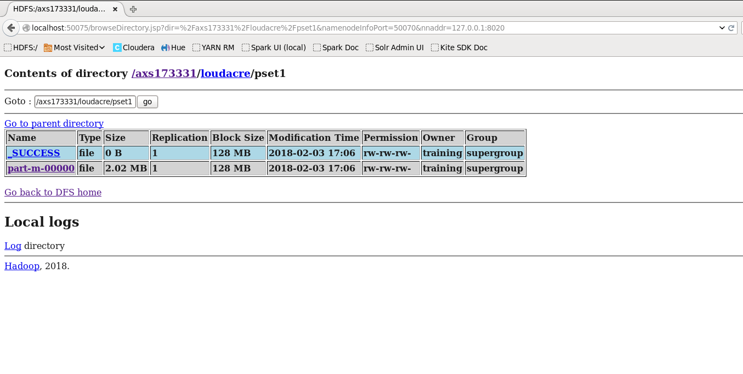

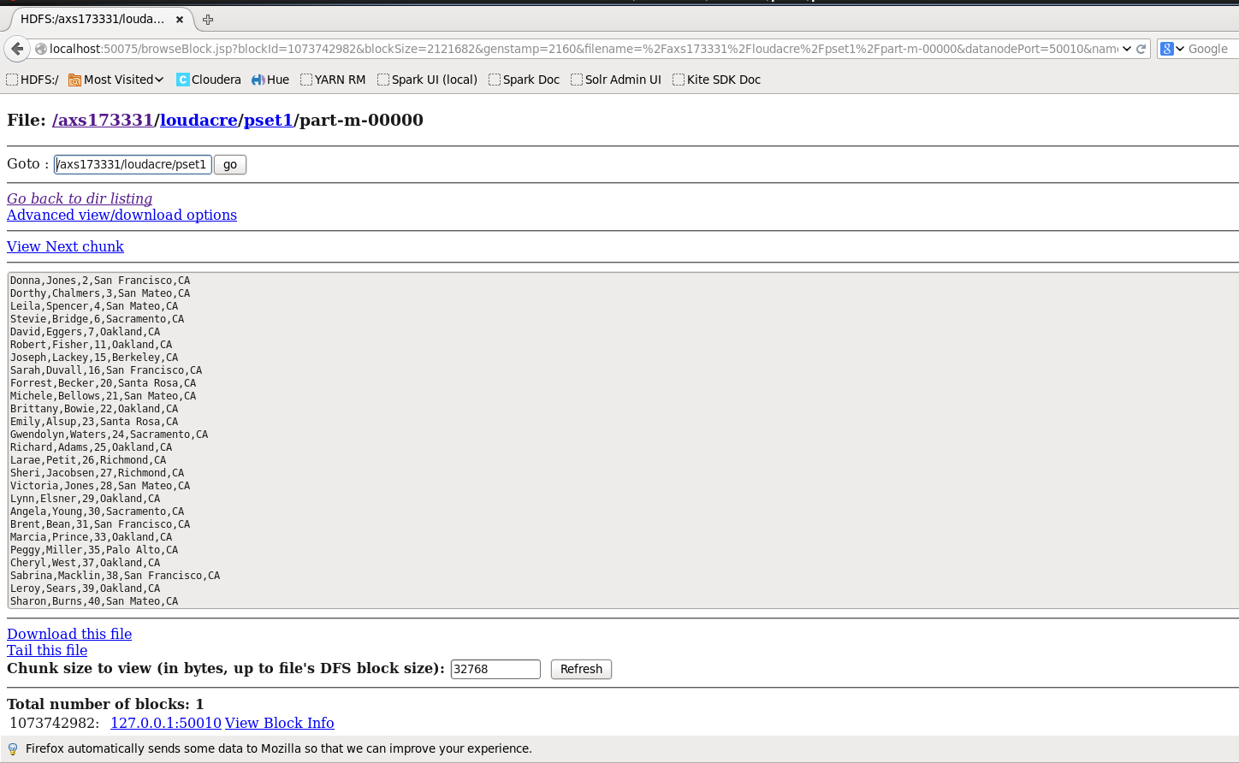

# Question 2:

## Command:

sqoop import \

--connect jdbc:mysql://localhost/loudacre \

--username training --password training \

--target-dir /axs173331/loudacre/pset2 \

--query 'SELECT first_name, last_name, acct_num, city ,state

from accountdevice join accounts on (account_id = acct_num)

where $CONDITIONS AND account_id IN (select account_id from accountdevice)

group by account_id having count(device_id)=2' \

-m 1

## Output:

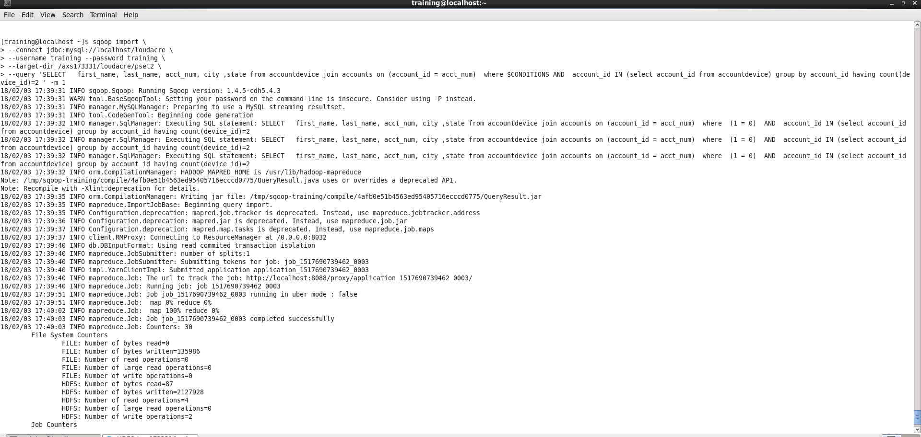

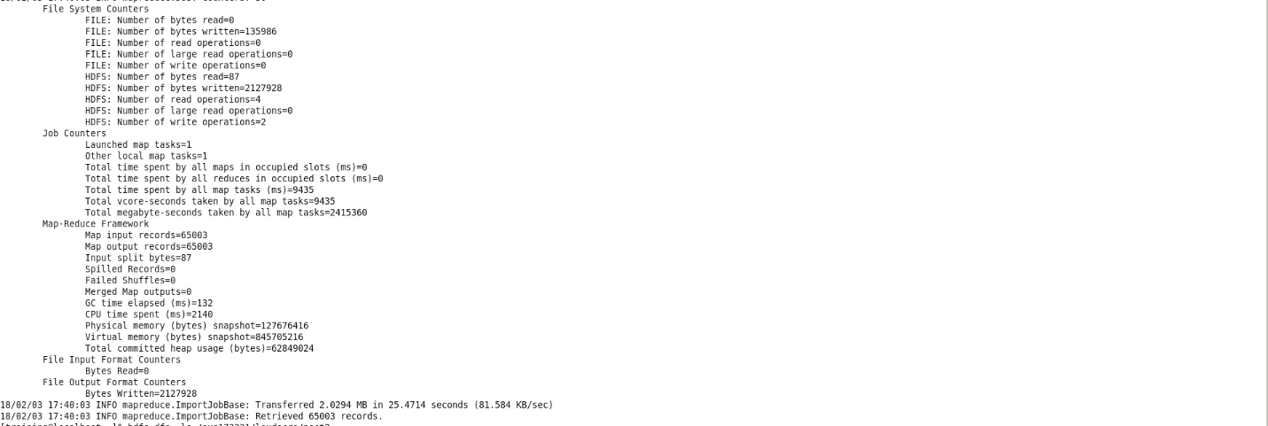

HDFS command line output

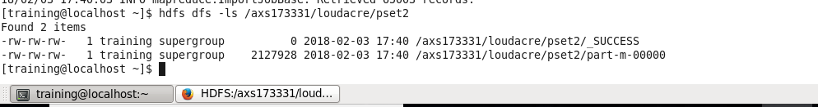

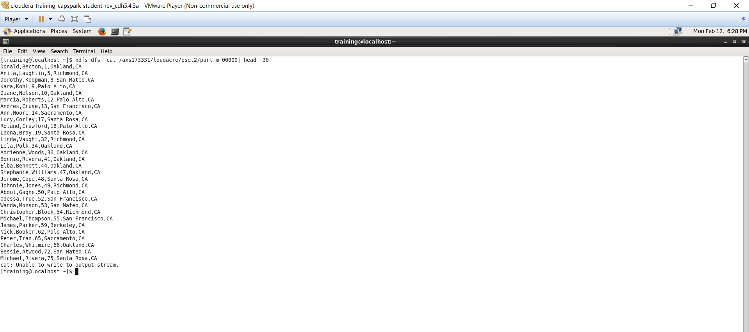

HDFS Browser output

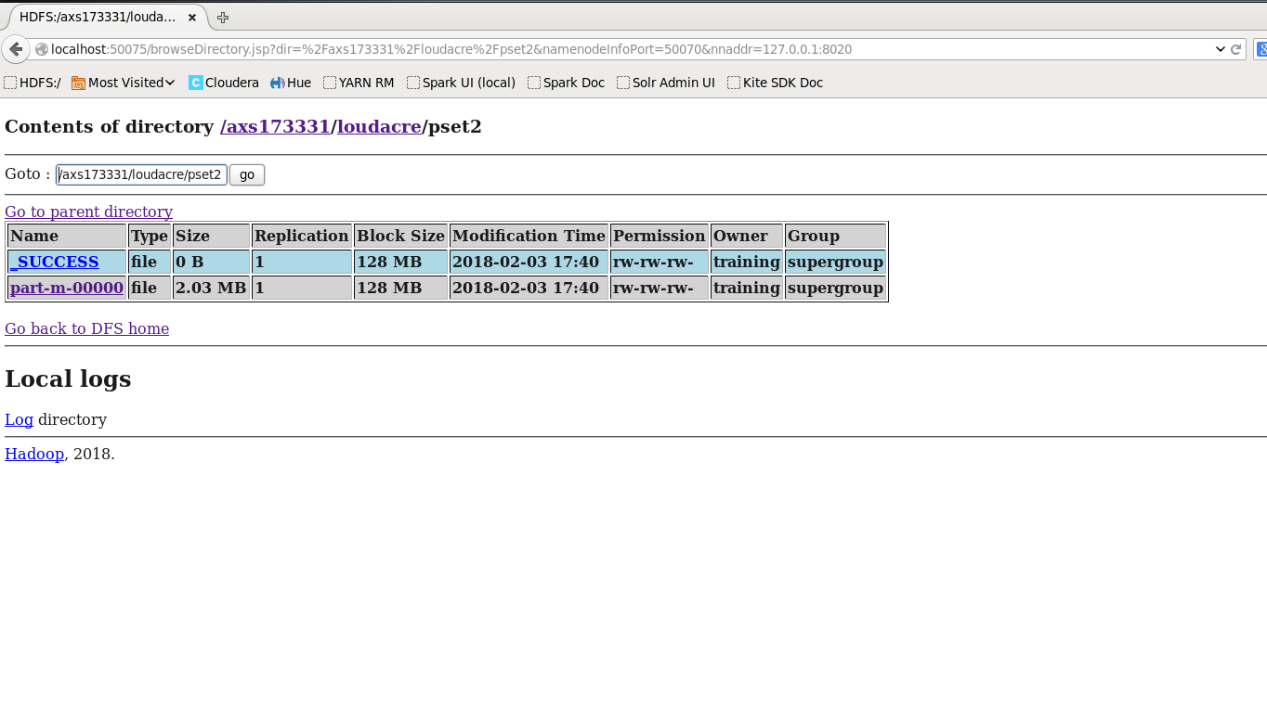

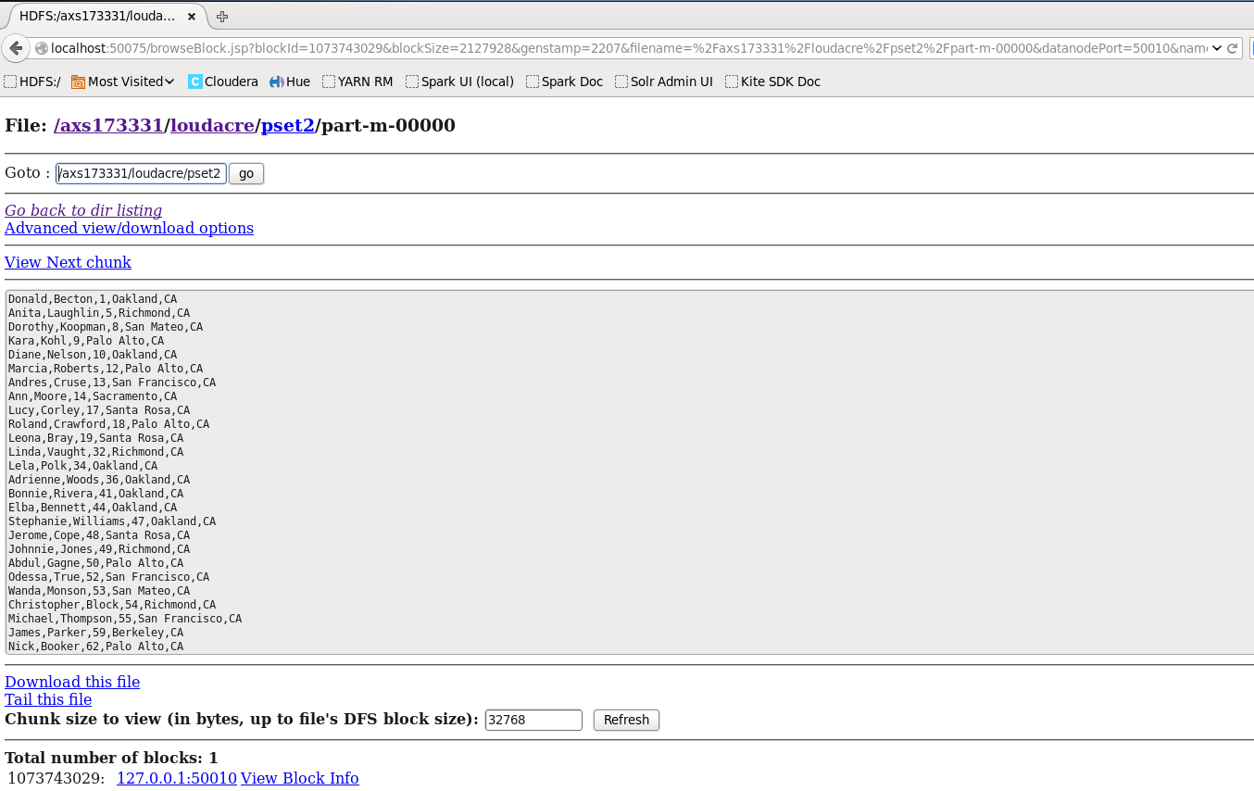

# Question 3:

## Command:

sqoop merge \

--new-data /axs173331/loudacre/pset1/part-m-00000 \

--onto /axs173331/loudacre/pset2/part-m-00000 \

--target-dir /axs173331/loudacre/psetmain \

--jar-file /tmp/sqoop-training/compile/4afb0e51b4563ed95405716ecccd0775/QueryResult.jar \

--class-name QueryResult \

--merge-key acct_num

## Output:

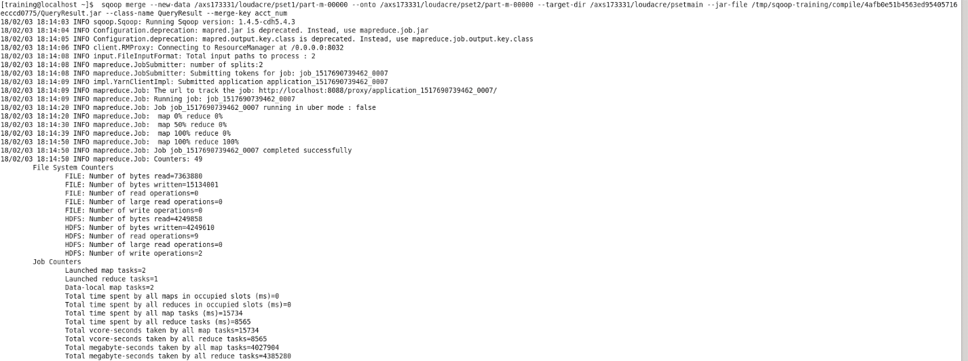

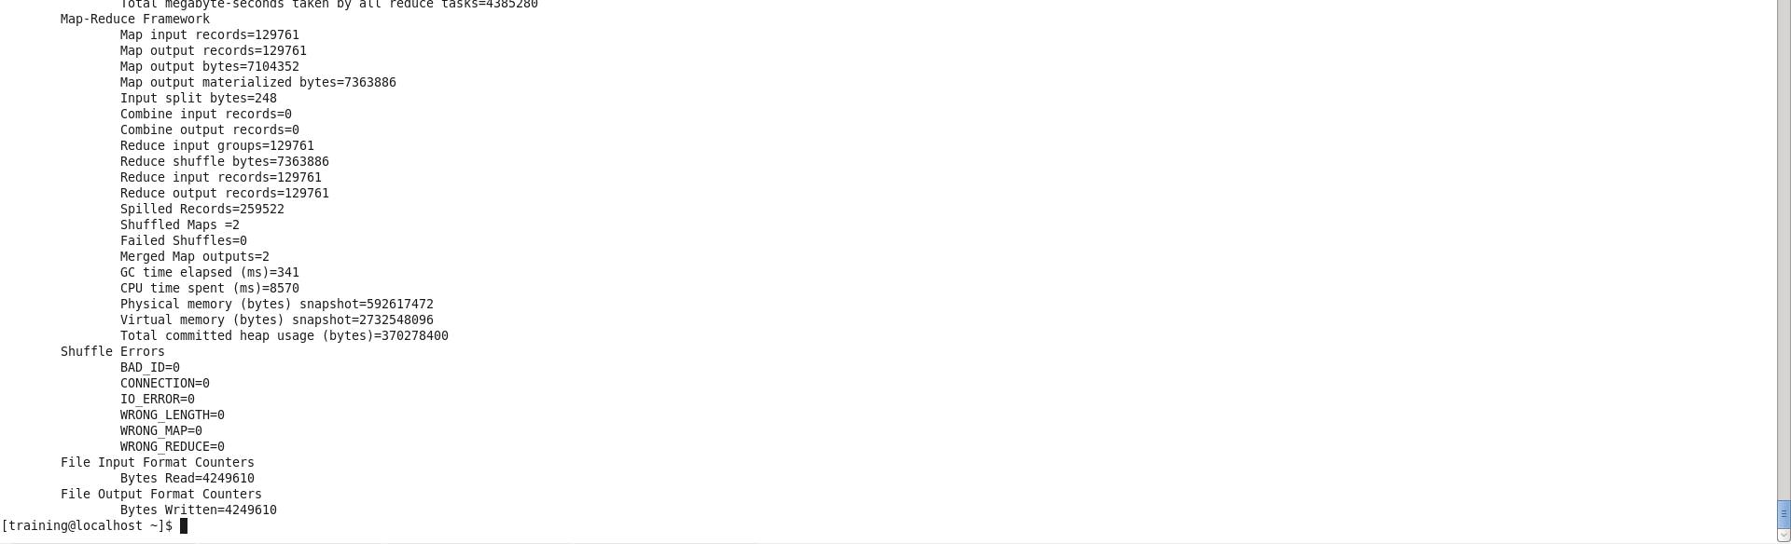

HDFS Command line Output

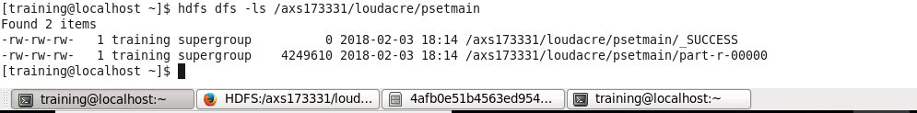

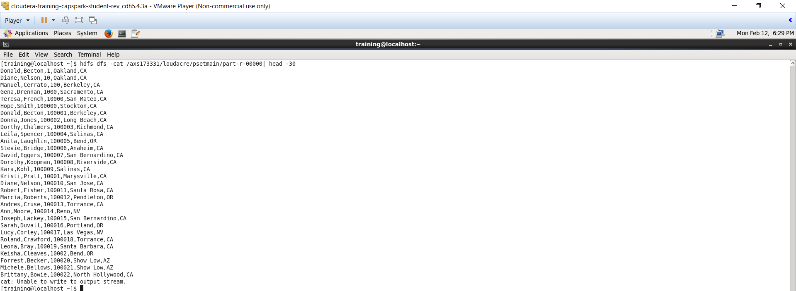

HDFS Browser Output

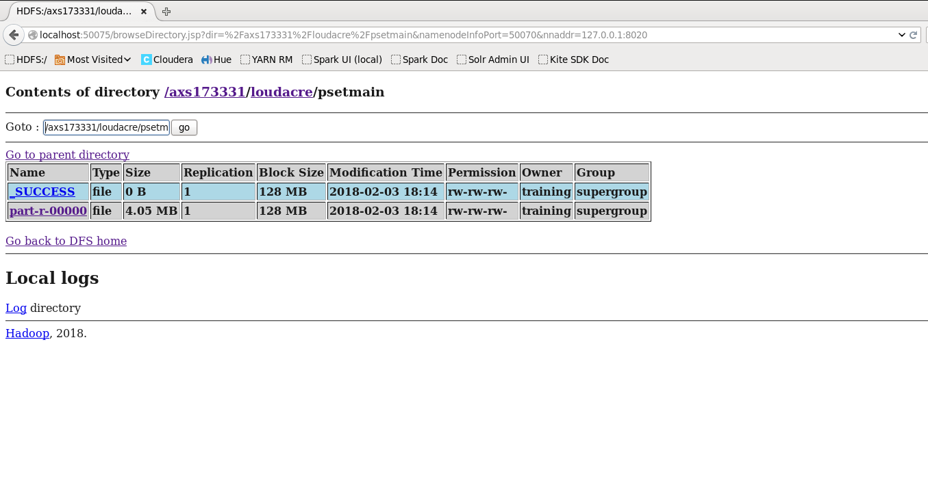

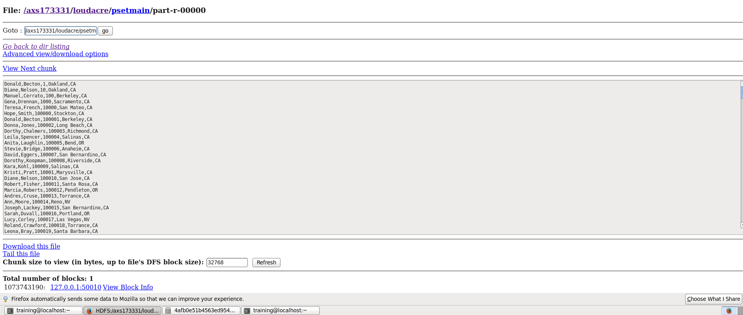

# Question 4:

## Command:

### Create MySQL Table

CREATE TABLE MergedAccts (first_name VARCHAR(255), last_name VARCHAR(255), acct_num int(11), city VARCHAR(255), state VARCHAR(255));

### Output

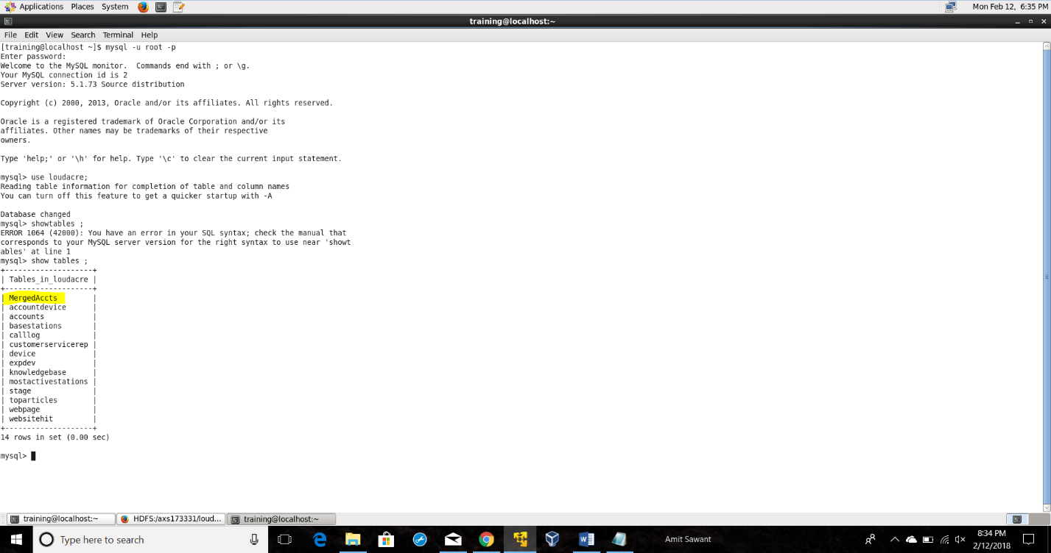

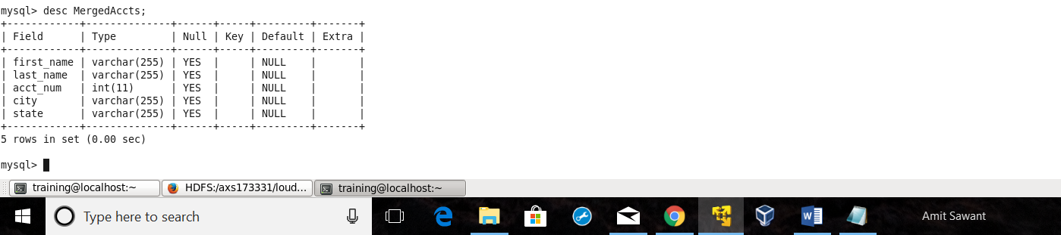

### Export Command

sqoop export \

--connect jdbc:mysql://localhost/loudacre \

--username training \

--password training \

--table MergedAccts \

--export-dir /axs173331/loudacre/psetmain/part-r-00000

### Output:

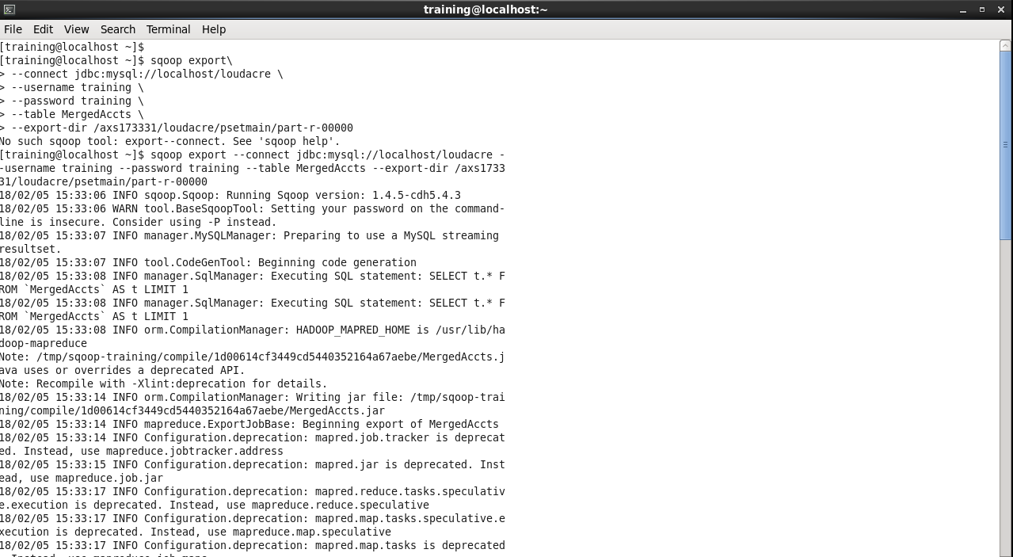

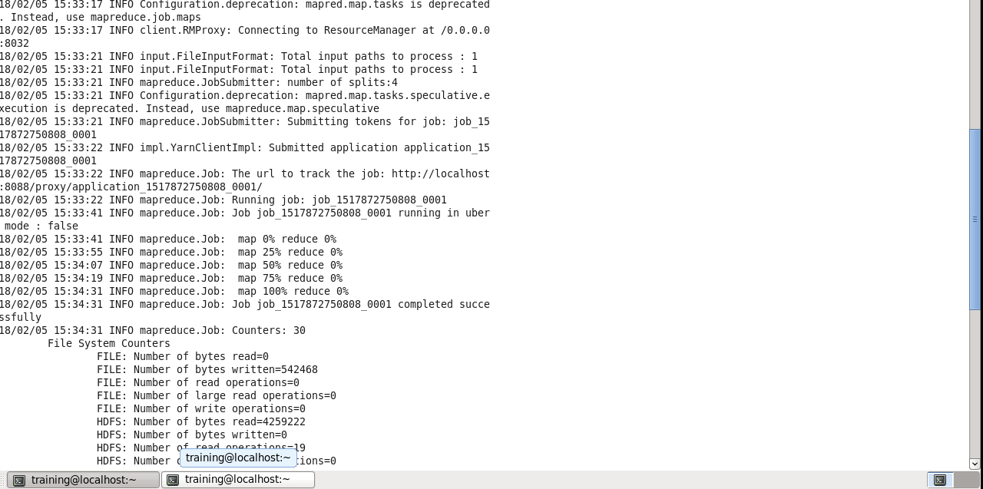

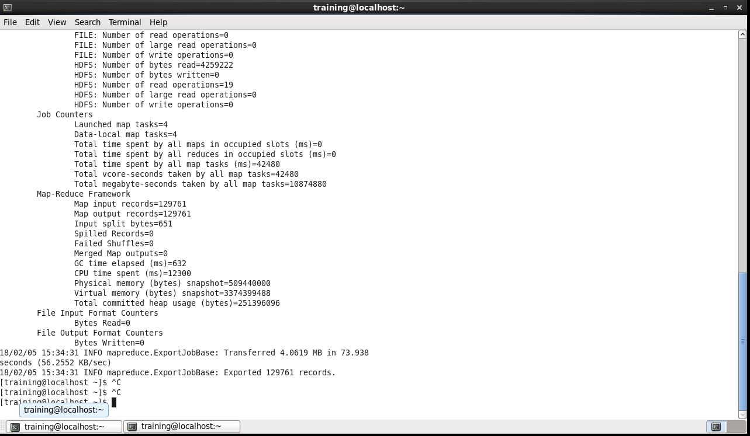

### Verifying Exported Records in MySQL

